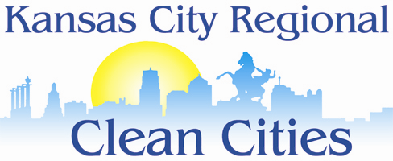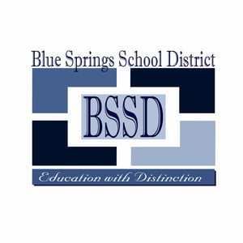

Calling all Transportation Officials, District Administrators & Managers, and School Board Members

**November 15th, 2017**

**9:00 am-2:00 pm**

**Bartow Administrative Center - 1801 NW Vesper - Blue Springs, MO 64015**

Panel Discussions, Presentations on Fuels and Technologies, and

a Behind-the-Scenes Tour of the Blue Springs District’s CNG Fleet

Facility

**School District Transportation Alt Fuel Summit**