AMPS AND BOLTS, NUTS AND VOLTS – EV ESSENTIALS FOR THE CURIOUS
(PART THREE)

DECISIONS, DECISIONS – As mentioned, buying a car is a big financial decision, and we can’t presume to dictate what meets your needs. Admittedly, efficient is good, more efficient is better, and we’re all in favor of zero-emission options here at MEC (yes, we’re somewhat biased). Even setting aside the positive environmental impact that moving away from petroleum creates, we believe that the case for electric vehicles is solid in terms of dollars and cents alone – your savings on fuel and maintenance over the lifetime of the vehicle can easily total thousands of dollars.

But in the end, the choice to switch from gasoline or diesel to an EV or PHEV needs to be a choice that works for you. What this closing installment aims to do is to connect you with resources that can help you run the numbers, check the tech, and learn from the experiences of others.

GETTING STICKY - Remember the last time you were at a car dealership? Remember the stickers on the rear windows of every car – the black & light blue stickers, with the MPG totals?

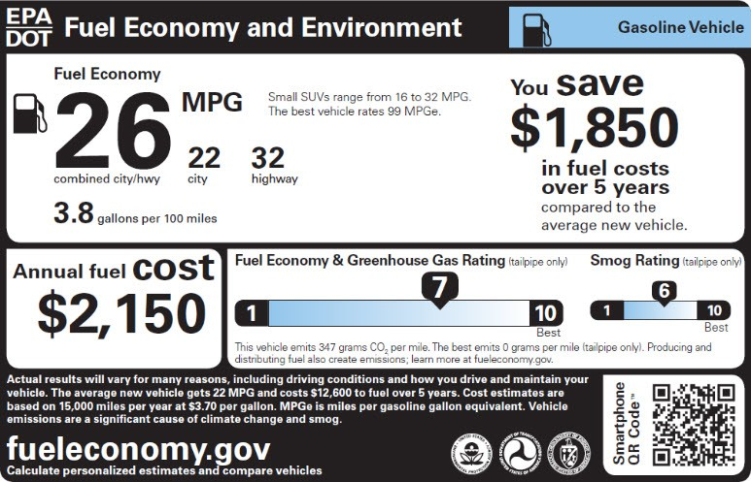

Yeah, those. All light-duty cars and trucks sold in the US get those numbers from federal laboratories, whatever their fuel. In the case of BEV and PHEV models, you’ll notice a substantial difference between a sticker for a conventional car, particularly when it comes to MPG and fuel costs:

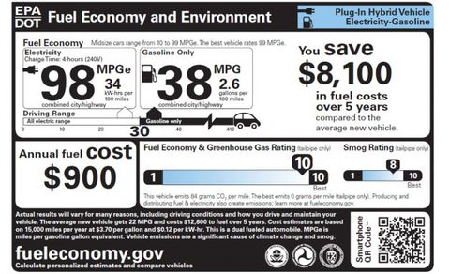
Handy in and of itself, this sticker is only the tip of an iceberg of information from federal agencies and laboratories available to prospective owners of any car or truck, powered by any fuel.
Let’s begin with the most popular and comprehensive federal site, Fuel Economy.gov, jointly supported by the Department of Energy and the Environmental Protection Agency. Once on the homepage, click on the tab labeled “Advanced Cars And Fuels” – the pop-up that results has no fewer than 47 different linked categories for everything from diesel to hydrogen.
Within these categories, there’s plenty to do. If you’d like to compare EV model to EV model, or compare PHEV to PHEV – or, for that matter, if you’d like to compare a Tesla with a Ford F-150, the interface is simple and intuitive. You can find estimates for five-year fuel costs, gallons or kilowatt-hours per 100 miles and even gas tank size, if applicable. Simple or detailed driving cost calculators, information on tax credits, personal online fuel efficiency tracking (for the slightly obsessive), and plenty more tools are here and ready to use. The same site also hosts the Fuel Economy Guide, which is annually updated, and the 2019 edition is now up and ready for free download.
A DIGRESSION IN THE NAME OF FULL DISCLOSURE – Once again, there’s no free lunch. There’s no tailpipe, but most electric cars have a smokestack – the power plant they plugged into. However, the Alternative Fuels Data Center has a calculator that shows how much carbon an average EV puts out in a year – and lets you compare it with hybrid, PHEV and gasoline options. It’s quite broad, and based on state averages. Even so, it’s fascinating to compare EVs in Missouri (coal-heavy) and Kansas (wind-rich) with their petroleum cousins– to say nothing of the yawning gulf between both states and California.
OWNER INPUT AND WEBSITES GALORE – Not surprisingly, there are lots of websites and owners’ groups out there. Given that this country abounds in organizations devoted to everything from Hendrix to Hummers to hummingbirds, it’s no surprise that there is plenty of information available in the EV and PHEV space, and plenty of user groups happy to talk cars with you, either digitally or in person.
Thinking Locally
There is a very active group of EV enthusiasts in the Kansas City area, and the members of the Mid-America Electric Auto Association would love to field your questions. Feel free to drop in at their monthly meetings (2nd Sundays at 1:00 at the Johnson County Main Library), or through their Yahoo user group. A point worth mentioning – MAEAA members know all about Kansas City weather - icy winters and blazing summers – and have experience with how weather impacts the performance of BEVs and PHEVs (it affects the performance of all vehicles, but that’s a subject for another time).
On The Web
InsideEVs is a solid catch-all site. They’re great at keeping up with tax credits and incentives, and their monthly sales scorecard is, if not formally approved by the industry, solidly based on monthly sales totals from all manufacturers. It’s also a good site for additional details on charging, financing and other, wonkier topics. Their charts on range, cost and incentives cover all available models and are regularly updated.
Green Car Reports A bit broader in scope, this site covers just about everything that is even faintly green in the auto world. Along with monthly updates on the best deals available, even for efficient conventional cars, the “First Drives” series covers new cars on the block, and their daily news updates are handy.
Midwest Evolve Hosted by a consortium of Clean Cities coalitions around the Midwest, ME covers a lot of ground and does so with efficiency. Their website has plenty of user-friendly breakdowns on EV and PHEV how-to, current auto show and ride-and-drive opportunities, and an excellent combination blog/news site.
Electric Auto Association One of the oldest EV organizations out there, the EAA has been promoting electric cars since 1967, when going electric was a 100% DIY proposition. Their website is a bottomless pit of information and links, particularly their EV Links page. Much of their content leans to the technical side, but there’s plenty applicable to those of us who are still in the “just looking” stage.
Please note that these are but a few of the many, many EV sites out there, whether run by non-profit organizations or businesses. We cannot vouch for 100% accuracy in what you may find there, particularly in online comments sections, which have an unfortunate tendency to resemble . . . online comments sections.

